Contact free digital thermometer
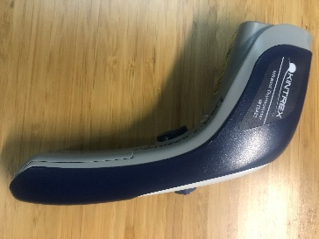
Helps locate air leaks and determine IF there is insulation in your walls without tearing into them.
Safety first! Do not look directly at laser beam or point at others. Best done on a cold day. Hold the thermometer about 1 foot from your wall and push button for temperature. It will not read shiny surfaces well. If necessary, put black or dull tape on the surface you want to measure – at least 2 inches by 2 inches. A well-insulated wall will be within 5 degrees of your room temperature. More than 15 degrees difference is an indication of very poor insulation or bad leak. Notice a difference from the top of the wall to the bottom as insulation settles over time. Air leaks will be significantly colder than adjacent walls.
See YouTube video for additional guidance. https://www.youtube.com/watch?v=Fy0pHGcgShs

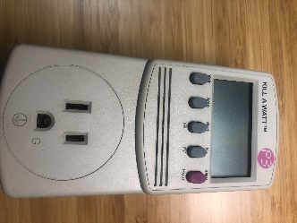
Kill-a-Watt meter
Measures power and energy of an appliance or other equipment over time (Does not work with 240V appliances (dryers or stoves). Limit 15 Amps.
How much energy does my TV or computer use in stand-by? How much does it cost me to run my extra refrigerator in the garage? What about the game console or other “phantom” loads for charging? See YouTube video for additional guidance. https://www.youtube.com/watch?v=1l_mo1jwh8Y or https://www.youtube.com/watch?v=rZ9s5J_-Qec
Safety first! Use caution when plugging and unplugging devices.
For stand-by energy or other constant loads,
- Plug the device into the meter and the meter into the wall. Use small extension cords as needed.
- Wait at least 60 minutes and record Watts.
- Press kWh button and then hours. Divide kWh by hours and 1000 to get average Watts.
- If both measurements are about the same, the load is pretty constant.
- Calculate annual costs = $0.12 x Watts x 8760/1000.
If the two values for kW are not similar or the load varies a lot (a refrigerator, for example)
- leave the meter plugged in for at least two full days or more
- then use the Watts = kWh x 1000/hours in the cost equation.

Caulk gun and caulk.
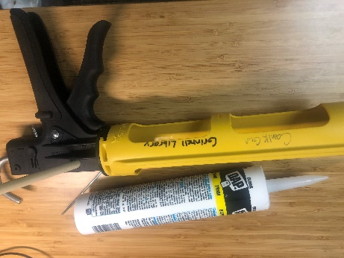
Weather sealing around window and door frames – small gaps.
How to tell if your frames are leaking badly: Best on a windy day, hold a smoldering (but not burning) incense stick near (but not touching) the wall along the window/door frame. If smoke blows away from or is sucked behind the frame, caulking would be beneficial. Keep a wet towel nearby for this test, in case the incense stick touches the wall or frame.
The caulk is yours to use. Leave un-opened caulk for others. The caulk gun conveniently clips the tube tip and can puncture tube internal membrane. See red circles in photo.
See YouTube video for guidance. https://www.youtube.com/watch?v=Qu8h3wSU__s or https://www.youtube.com/watch?v=6-EgXgGlO2Q

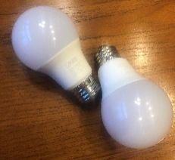
LED lightbulbs - 60W Incandescent equivalent
Efficient and appealing alternative to incandescent or compact fluorescent lights.
Yours to keep. Leave unused new LED bulbs for others. Install in heavily used lights. Each bulb will save $4.25 per year in lamps that are on 2 hours per day.

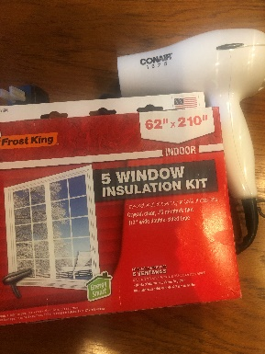
Window film and hair dryer
Adds an extra layer of material and stops leaks past window sashes to reduce waste and keep you warm.
Film is yours to keep and use on about 5 windows (3x5 feet). Leave hair dryer and unused material for others or keep the unused film for next year. Best used on known leaky windows or windows with missing or broken storm windows.
Safety first! Do not use dryer near open water or rest hot end on flammable material after use. Read instructions on package and watch YouTube videos for installation guidance. https://www.youtube.com/watch?v=F9Ne50TfPn4 or https://www.youtube.com/watch?v=3PkFKG4b7ic or https://www.youtube.com/watch?v=A0hJ5D8UAqU
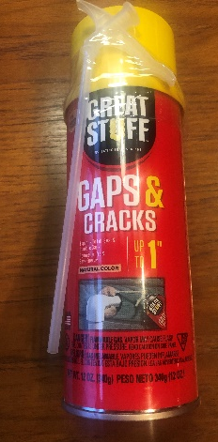
Great Stuff® Gaps & Cracks sealer
Stops bigger leaks – but messier. Use to seal leaks around exterior wall penetrations: around hose bibs, dryer vents, Cable TV access, exterior outlets, for example.
Yours to keep. Leave unused cans for others. Follow instructions on the can and clean surfaces. Watch YouTube videos for installation guidance. Safety first! Wear protective gloves and safety glasses.
https://www.youtube.com/watch?v=qxEuetgHBWU or https://www.amazon.com/Great-Stuff-99108824-Dispenser-Sealants/dp/B07GLG7B3Z or https://www.youtube.com/watch?v=6DoEoDZtbQ0
For even larger gaps, the library has more professional installation applicators for use with larger cans. Cans of foaming material and cleaning solution are NOT included for these applicators.

https://www.imaginegrinnell.org/

